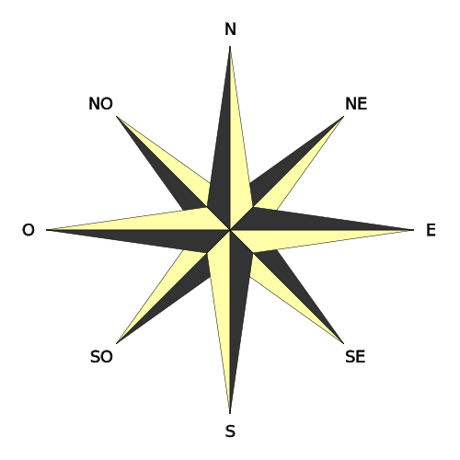

What is guidEU?

The guidEU project's main aim is to prevent dropping out of school and disengagement from the labour market through provision of personalised, high-quality career guidance system and tools supporting lower and upper-secondary students with career explorations and overcoming shortages of highly trained counsellors.

The project sets up to build strong links between schools, training institutions, employers and parents across countries to best link curricula to international employment opportunities, reduce mismatches in skills and career choices.

Project number: 2016-1PL01-KA201-026801

guidEU

www.guideu.net

This project has been funded with support from the European Commission under Erasmus + Programme. This publication (communication) reflects only the views of the author, and the Commission cannot be held responsible for any use which may be made of the information contained therein.

Purpose and overall goals

* **Reduce early school dropout through professionalized career guidance**
* **Overcome shortages of counsellors at schools**
* **Enrich scarce offer of free-of-charge and barrier free tools for the recognition of students' career predispositions and interests to be used on their own**
* **Enrich scarce offer of career-oriented materials and free-of-charge tools for guidance counsellors, devoid of technological barriers to the computer use**
* **Improve career guidance services through engaging tools, methods, linking school curricula to international job opportunities**
* **Foster youth provision, equity on the labour market**

Project Outcomes

* **Benchmark Report with career e-guidebook to determine key dimensions of high-quality career guidance in international context, while addressing the validity of the project tools/ outputs and expectations.**

* **On-line career aptitude tool to diagnose and measure lower and upper-seconday students' professional skills and predispositions, with unattended execution of test components and automatic generation of assessment report**
* **"Get to know the labour market" game - useful and ready asset for students to understand the labour market.**
* **Training toolkit**
* **Teacher’s guideline on how to implement the developed game into the classroom**
* **Guidance counselling lesson plan, involving all the developed tools**
* **Action Plan for lkower and upper-secondary students.**

Zespół Szkół Ogólnokształcących w Dęblinie