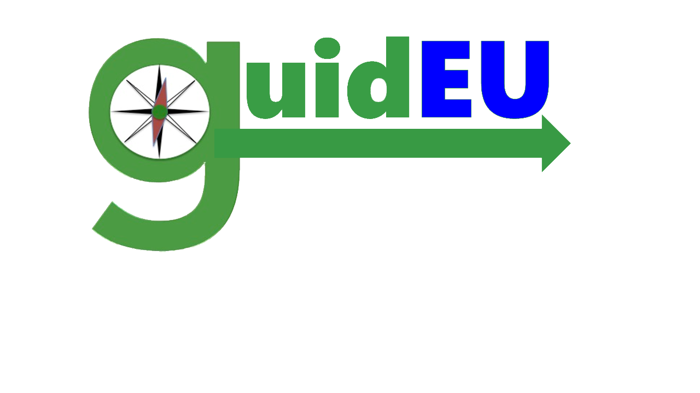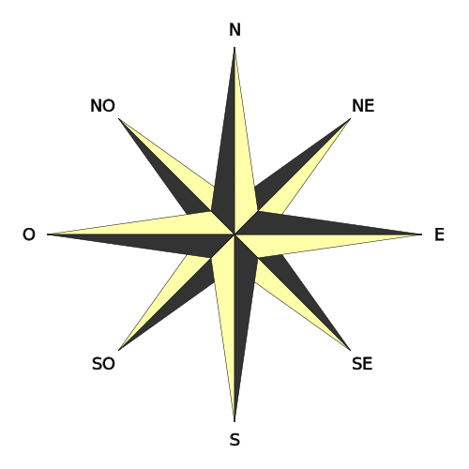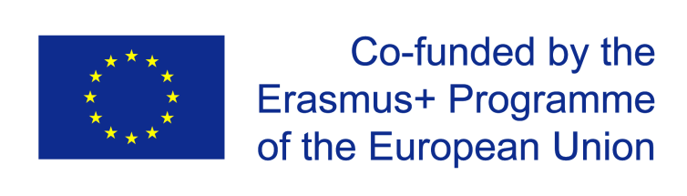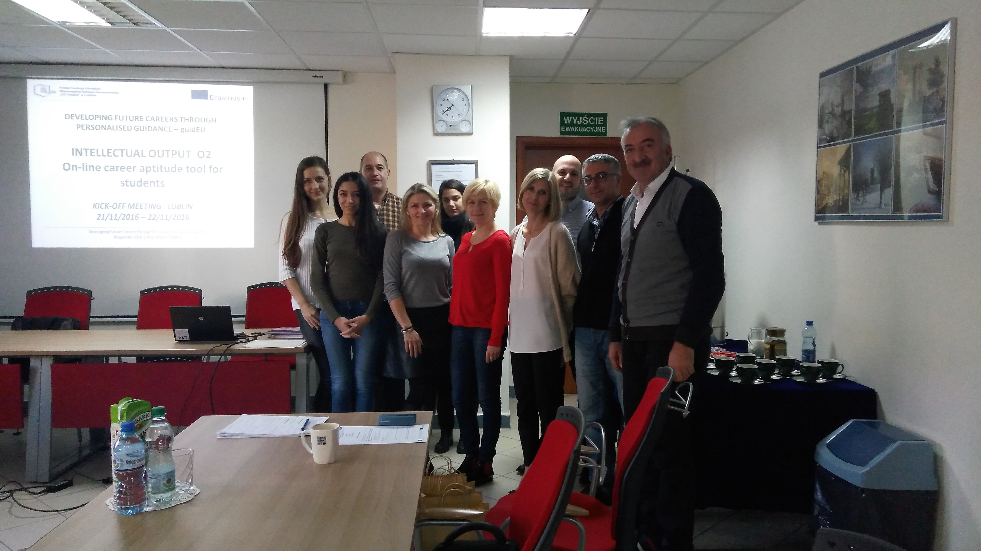

#### WHO IS IT FOR?

The guidEU project responds to the Europe 2020 priorities in the area of education and training, youth and early school leaving in the context of globalization, free cross-border movement of workers and labour market integration. Project's main aim is to prevent dropping out of school and disengagement from the labour market through provision of personalized, high-quality career guidance system and tools supporting pupils with career explorations and overcoming shortages of highly trained counselors.

The project sets up to build strong links between schools, training institutions, employers and parents across countries to best link curricula to international employment opportunities, reduce mismatches in skills and career choices centers and stakeholders. The project consortium is a complex partnership engaging both private and public schools and organizations, institutions active in the field of education/training coming from 4 European countries - Poland, Cyprus, Turkey and Spain.

* Lower and upper-secondary school students
* Educational establishments
* Guidance counselors
* Practicioners
* Teachers involved in the aspects of educational and vocational counselling
* Lower-secondary and/or upper-secondary school experts
* Recruiters
* HR managers
* Euroguidance network
* KeyCoNet network
* Parents
* Educational institutions offering guidance services
* Guidance and counselling centers
* Job centers

OTHER RELEVANT STAKEHOLDERS

INDIRECT TARGET GROUPS

##### **DIRECT TARGET GROUPS**

What is guidEU project?

**www.guideu.net**

DEVELOPING FUTURE CAREERS THROUGH PERSONALISED GUIDANCE-guidEU

ISSUE 1- FEBRUARY 2017

**1. Output 1: The Benchmark Report accompanied by career e-guidebook**

The Benchmark Report will determine key dimensions of high-quality career guidance in international context, while addressing the validity of the project tools/ outputs and expectations a target group holds regarding them. It will be used as a point of reference to shape the tools/outcomes (O2-O4) accordingly. It will be accompanied by career e-guidebook.

**2. Output 2: On-line career aptitude tool for students aptitude**

On-line career aptitude tool will be designed to diagnose and measure pupils' professional skills and predispositions. Unattended execution of test components and automatic generation of assessment report will allow for the independent use of a tool, both among students, parents and any individuals with no formal qualifications in psychology or career counselling.

**3. Output 3: Get to know the labour market - game**

The game will be a useful and ready asset for students to get to know and understand the labour market, hiring process and get first, real-life insights into the workplace. In the game, students will have to carry out the tasks as correspondent to the particular moves on the board in reference to the labour market understanding; self-awareness; things to consider when choosing a career etc.

**4. Output 4: Training Toolkit**

The training toolkit will be geared towards career counselling experts (teachers, counsellors, trainers, educators) and will be composed of ready-made materials to work with, i.e. teaching package for guidance school counsellors, practicioners and teachers/ educators involved in the aspect of counselling; scenarios of lectures for pupils in professional counselling - face-to-face advice and guidance and updated version of the career e-guidebook. It will be complemented by:

b) Teacher’s guideline on how to implement the developed game into the classroom

c) Guidance counselling lesson plan, involving all the developed tools

a) Action Plan for pupil

# What results are expected ?

**www.guideu.net**

ISSUE 1- FEBRUARY 2017

# The kick-off meeting of the project

**www.guideu.net**

The kick off meeting of the project took place at the coordinators' premises, the OIC Poland Foundation, on the 22nd and 23rd of November.

During the meeting, the project and overall activities were presented as well as the immediate actions to be taken were set and agreed among the consortium.

On the first day the meeting started with a brief presentation of the partners followed by the overview of the guidEU project and the development of the project outputs:

The Benchmark Report (O1), On-line career aptitude tool for students (O2), Get to know the labour market game (O3) and Training toolkit (O4).

The session ended with the presentation of the short-term joint staff training event in Poland (C1) and short-term exchanges of students in Spain (C2) and in Turkey (C3).

On the 2nd day, the dissemination and exploitation activities were presented, as well as the quality control, monitoring and evaluation and the administrative/financial obligatory regulations. The session ended with the agreement of the scheduled upcoming activities and project meetings and the summary of the meeting.

All partners, coming from Cyprus, Poland, Spain and Turkey, are enthusiastic about this new educational journey!

ISSUE 1- FEBRUARY 2017

Currently the partners are conducting the Desk research, examining published materials and looking for best practices in high-quality career guidance services across Europan countries.

The broad understanding of the career guidance field and practices in project partner countries will allow to form the firm foundation on which the project outputs will be built.

TAKE PART IN THE PROJECT

PARTICIPATE IN SURVEY

Next stage will be **the fieldwork research** to collect information from project target groups (career guidance cousellors, head of schools, teachers, educators, parents and other relevant stakeholders) on available and used career guidance tools, services and implemented practices especialy at secondary school stage.

The partners will also survey pupils to hear of the expectations they have towards career guidance classes and opinion on the applied classroom solutions.

The questionnaire survey shall be carried out in each country on a group of:

* 20 teachers/ guidance counsellors of III and IV educational stage
* 10 representatives of relevant stakeholders /parents, experts in educational field, chief executive officers of school districts, academic staff/
* 20 students of lower secondary and upper secondary schools

The collective survey feedback from all project partner countries combined with the results of the Desk Research will be available in the Benchmark Report by the end of May this year.

If you want to join the project and voice your opinion on career guidance in the international survey, please contact your national partner.

# What´s next?

**www.guideu.net**

ISSUE 1- FEBRUARY 2017

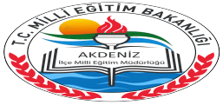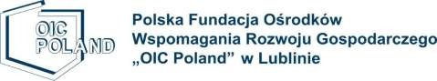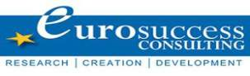

OIC POLAND FOUNDATION

[www.oic.lublin.pl](http://www.oic.lublin.pl/)

Ewelina Iwanek

[ewelina.iwanek@oic.lublin.pl](mailto:ewelina.iwanek@oic.lublin.pl)

AKDENİZ İLÇE MİLLİ EĞİTİM MÜDÜRLÜĞÜ

<http://akdeniz.meb.gov.tr>

Ahmet Callut ŞAHİN

[ahmet.c.sahin@gmail.com](mailto:ahmet.c.sahin@gmail.com)

CPR PLURILINGÜE NUESTRA SRA DEL CARMEN

www.atochabetanzos.com

Juan Antonio González Parga

atochabeteuropa@hotmail.com

Z**espół Szkół Ogólnokształcących w Dęblinie**

Kinga Lazarska

[kingaruszuk@gmail.com](mailto:kingaruszuk@gmail.com)

HIGHGATE PRIVATE SCHOOL LTD

[www.highgateschool.ac.cy](http://www.highgateschool.ac.cy)

Antreas Antreou

antreasa@highgateschool.ac.cy

**www.guideu.net**

EUROSUCCESS CONSULTING

[www.eurosc.eu](http://www.eurosc.eu/)

Giorgos Giorgakis

[george@eurosc.eu](mailto:george@eurosc.eu)

The Project Consortium

ISSUE 1- FEBRUARY 2017