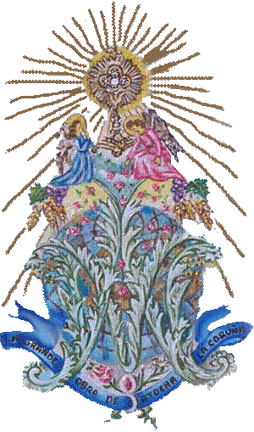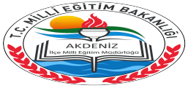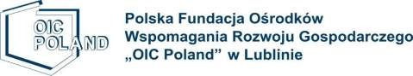

This project has been funded with support from the European Commission under Erasmus + Programme. This publication (communication) reflects only the views of the author, and the Commission cannot be held responsible for any use which may be made of the information contained therein. PROJECT NUMBER: 2016-1-PL01-KA201-026801

**www.guideu.net**

**Zespół Szkół Ogólnokształcących w Dęblinie**

guidEU

CPR Plurilingüe

Nuestra Sra del Carmen